Jimmy Reiter Caught Up In The Blues
Release Date DEC 4 2026, PogoPop Musik / Timezone, CD (Digipak) / LP (180g VinYl), StreaMing

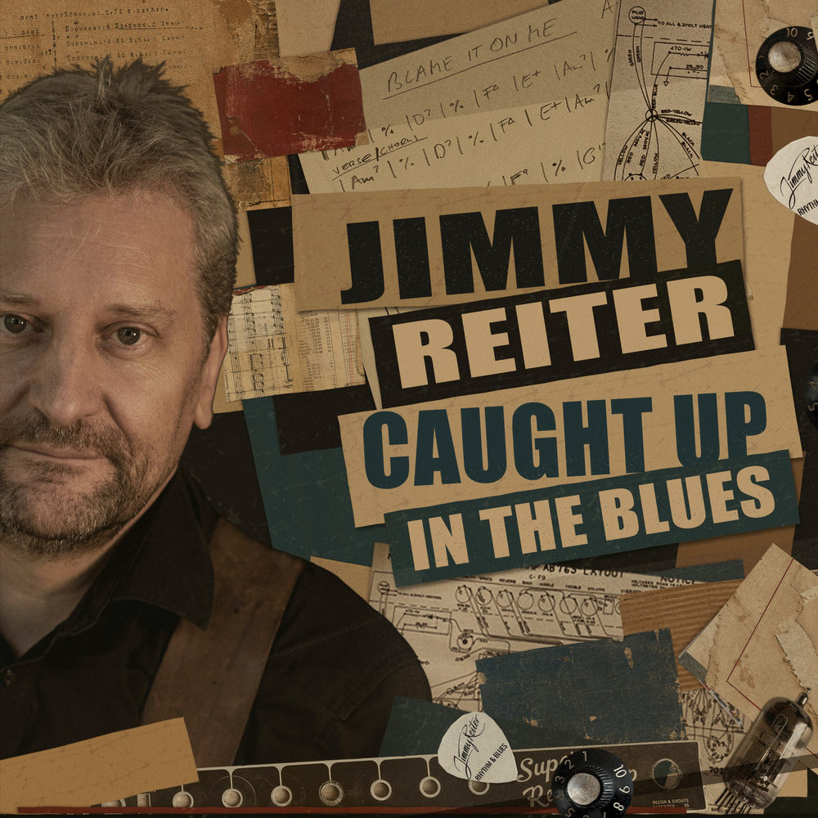
They say the blues is music about heartache and empty refrigerators. Jimmy Reiter’s fridge is nobody’s business – but the past few years have certainly given the 50-year-old guitarist and singer the blues. His marriage came to an end, and within a short span of time, he lost three people who were close to him. Those experiences run deep through Caught Up In The Blues, his new album.
The record is Reiter’s fifth – and easily his most personal to date. For years, he and his band have been among Germany’s most accomplished purveyors of rhythm & blues. Here, Reiter turns the events of recent years into songs with remarkable honesty. The title track and “Thief In The Night” address those experiences head-on, while Caught Up In The Blues never sinks into gloom. The encouraging “You Can Count On Me” and the hard-driving “Cramp Your Style” bring light, energy and momentum to the record.
Blues, soul, funk and R&B come together in a sound that is rooted in tradition but never trapped by it. Reiter’s finely crafted songs, expressive guitar work and unmistakable tone take center stage, bolstered by a powerful three-man horn section. Over ten tracks and some 43 minutes, the Osnabrück native once again makes a compelling case for his place among Europe’s essential blues and soul artists.
His affection for the music of New Orleans is unmistakable in “Whoever’s Thrilling You (Is Killing Me),” a deep cut originally recorded by R&B legend Ernie K-Doe. Elsewhere, “Cold Comfort” offers one of the album’s most atmospheric moments, pairing Reiter’s soulful, deeply felt guitar playing with warm, velvet-smooth backing vocals.
Drummer Björn Puls and bassist Jasper Mortier have been at Reiter’s side since his first album. Together with keyboardist Horst Bergmeyer, they form a seasoned, intuitively connected band that supplies the record’s deep groove and rhythmic punch. Caught Up In The Blues was recorded with Marcus Praed at Mühle der Freundschaft in Bad Iburg.
“Being in the studio with the band always feels like a vacation to me,” Reiter says. “Seeing ideas I first came up with in my little home studio come alive and eventually turn into small works of art is always an incredibly moving experience.”
Caught Up In The Blues will be released on December 4, 2026, on CD and LP, and will be available on all streaming platforms.

